Screaming balloon!

Did you know you can make a balloon scream?
Well, you can! It's easy to do, lots of fun and you can learn about how sounds are made too!

What Do I Need?
- Balloon
- Nut (sometimes called a hex nut)
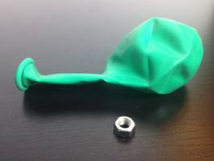

How Do I Do It?
STEP1 - This experiment is super-easy. You'll be making an awesome wiring noise in a matter of seconds! First put the nut inside the balloon.
STEP2 - Blow up the balloon with the nut inside and tie it up.
STEP3 - To really start on your nutty experiment you'll need to rotate the balloon gently and smoothly till the nut starts to spin around and around. The easiest way to do this is to have the balloon 'upside down' as shown and to gently spin it round in a horizontal motion till the nut starts to spin.
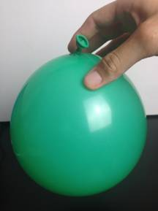

What’s Going On?
Now you'll be hearing an awesome but pretty weird noise, let's find out why!
Every single sound you ever hear in your whole life is caused by a 'vibration'. When someone talks their throat vibrates, when you bang a drum the skin of the drum vibrates and that's what makes the noise.
The beautiful screech that you're hearing is the balloon itself vibrating. The angles on the nut scrape across the surface of the balloon and make it vibrate - making that cool noise!

