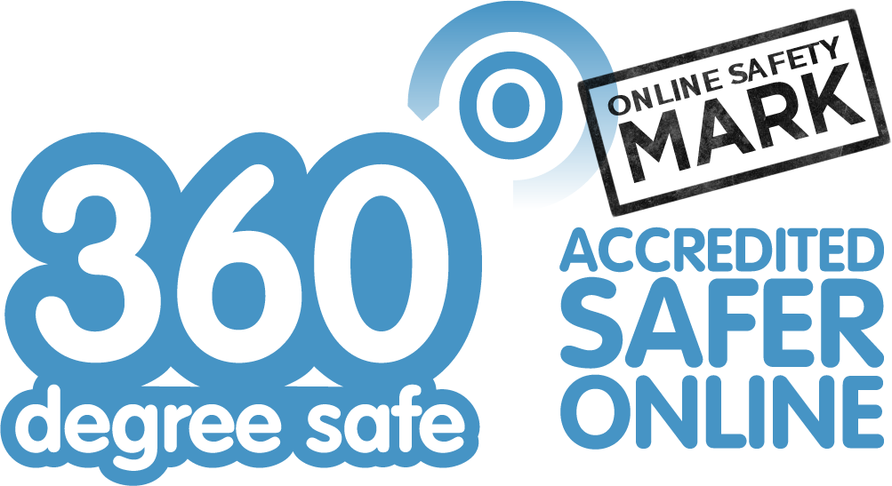
This is to certify that
St Oswald’s CE Primary School
was awarded the 360 degree safe Online Safety Mark by SWGfL through a desktop
assessment of the quality of their online safety provision on June 15th, 2020.

Provided By: | South West Grid for Learning Trust Ltd (SWGfL) is a not-for-profit charitable trust company, providing schools with fast reliable internet connectivity and services, learning technologies to improve outcomes, and toolkits for being safer online. | Certified By:

