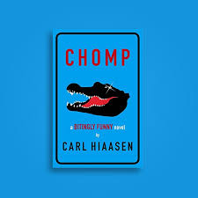
My Book Recommendation
By Basil
Chomp is a story about a poor animal-loving family who were desperate to do anything to protect their animals. There’s a mother who was forced to travel to China for a job; a father who was, non-officially but might have been, the best animal-wrangler there was; the child who was much like his father. They were offered a job in a survivalist TV show, providing the animals. As they love animals, they would do as much as possible to protect them, which proved hard when all this crazy, egoistic, so-called survivalist wanted to do was wrestle the wild pets. In this book, you meet many weird and wonderful (but mainly weird) characters. Friendships and enemies are scattered all throughout.
I particularly recommend this book because it teaches all about: not killing animals and how their lives matter as much as ours; being grateful for what we have and not being greedy and last but not least it’s about not believing everything you see on TV!
I’d recommend this book to teenagers or young adults as it’s quite lengthy and the vocabulary is rather challenging; the themes also appeal to an older audience.

In conclusion I’d rate it this book:

