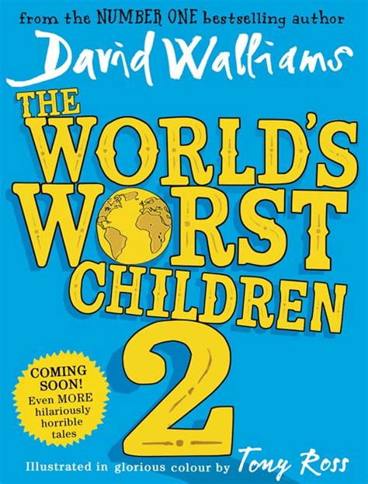
My Book Recommendation
By Fatima
World’s Worst Children 2
By :David Walliams
The brilliant follow-up to David Walliams’ bestseller The World’s Worst Children! It contains ten more stories about a brand new gang of hilariously horrible kids from everyone’s favourite children’s author, David Walliams. The children are disrespectful but usually get their comeuppance. Illustrated in glorious full colour by Tony Ross, makes for an exciting- but not too challenging text- for young children and older children alike that everyone can relate to.
I recommend this book ‘World’s Worst children 2 ‘ because it is a great fiction book that shows how kids can sometimes be (in parts it is quite realistic!). The characters are: Humbert the hungry baby, Stacy Superstar, Fussy Frankie, Gruesome Griselda, Spoiled Brad, Cruel Clarissa, Harry who never does his homework, Competitive Colin, Trish and No No Noe who only ever uses one word.
In conclusion I’d rate it this book:

