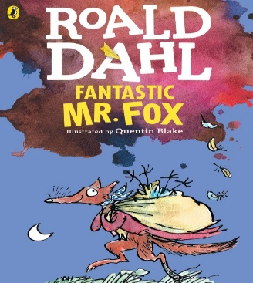
My Book Recommendation
By Saif M
Fantastic Mr Fox by Roald Dahl
Fantastic Mr. Fox: Is a story about a family of foxes and other animals in the forest who need food for the upcoming winter. Things aren’t so simple as they face many obstacles and difficulties. To complete this mission, animals need to be cautious of the frightening owners of the farms who are:
Boggis: a chicken farmer, Bunce: a duck-and-goose farmer
and Bean: a turkey-and-apple farmer.
This story shows how cleverness and logical thinking leads to success and achieve goals. Mr. Fox led about 30 animals including moles, foxes , badgers, rabbits and weasels to reach the three farms to get their needs. This adventurous story is full of unexpected events and breath-taking actions.
My best character is Mr. Fox because of all his character traits, including leadership, grit, confidence, self-control, and focus. He is also a kind and a happy character.
My favourite part was when the farmers kept waiting for the animals as it showed how unintelligent they are compared to the animals.
This is what Mr. Fox said when he was telling his team of animals what to do. “Thank you , but now , my friends let us be serious, Let us think of tomorrow and the next day and the days after that. If we don’t we will be killed. Right?”
Read to find more about this marvellous mission!
This is quite an easy read for Year 6 but a great story nevertheless. I would recommend it for Year 3 or Year 4. As a story with a great plot and interesting characters I would rate it:

